ABTAPL Spring Conference  ibis Edinburgh Centre South Bridge and  New College, University of Edinburgh  Thursday 21–Saturday 23 March 2024 | 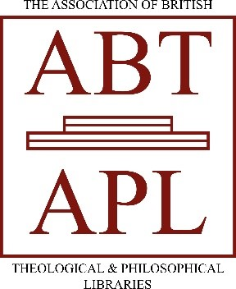

Please submit your form with confirmation of your payment by Monday 12 February 2024 at the very latest.
If you cancel your attendance after 12 February, we cannot guarantee a refund. Please be sure you can attend before submitting your form.
Please email your form to sarah.mann@mac.com. If paying by cheque, please email sarah.mann@mac.com before the end of 12 February, and post the cheque to the London School of Theology address at the end of this form.
I / We wish to attend the ABTAPL 2024 Spring Conference at the following fee (please tick):

 | Full | Concession* | Early bird  (book by 31 January)
Delegate | £250 | £175 | £225
Delegate and accompanying partner | £342 | £329 | £320
Non-residential delegate | £112 | n/a | n/a
Day rate | Friday: £50  Friday with meal: £70  Saturday: £30 | n/a | n/a
*Concessions apply for: retired members; unwaged personal members.
Name:

Partner’s name (if applicable):

Institution (if applicable):

Contact postal address:

Email address:

May we share your email address with other delegates? | Yes / No
Daytime and/or mobile phone number

Will this be your first ABTAPL conference? | Yes / No

Contact in case of emergencies

(Note: this must not be someone attending the conference.)

Name: | Phone number: | Relation to you:

Please indicate any dietary requirements: | Delegate Partner
Please indicate any accessibility requirements: | Delegate Partner
Please indicate if you do not consent to being photographed during the course of the conference: | Delegate Partner

BACS payment details  Please use payment ref: nameSprC24 (where name is your surname)  Account/Payee Name: ABTAPL  Bank Name, Sort Code and Account Number: Co-operative Bank; 08-92-99; 65667284  IBAN Number, Swift Code, and Routing Number (US Only): IBAN: GB53 CPBK  08929965 6672 84  BIC: CPBK GB22 | Payment made? (Please tick if so.)
We prefer direct bank payments.

Cheques should be payable to ABTAPL and returned with your form to:
Keith Lang, Librarian, London School of Theology, Green Lane, Northwood, Middlesex, HA6 2UW

Invoices or information on bursaries can be provided on request. Please contact Keith Lang at London School of Theology, Green Lane, Northwood, Middlesex, HA6 2UW abtaplinfo@gmail.com

***You are not booked until you receive confirmation from ABTAPL. If you have not heard from us by 26 February 2024, contact Sarah Mann.***

